

**CS6140 Machine Learning**

**By: - Prof. Ehsan Elhamifar**

**Human Activity Recognition Using**

**By: - Group No 21**

**Swati Kumari**

**Saurav Rohidas Palekar**

***Abstract: -***

***The activity recognition is the process of tracking human activities using smartphones, and human activity recognition is a deep learning data frame which collects raw data from smartphone equipped sensors such as accelerometer and gyroscope and observes the human movement. This is the case of signal processing and requires deep learning expertise to address the problem. The applications of this problem are very wide, with human activity recognition to GPS, entertainment to assisted ambient living. Our goal is to select the best machine learning and deep learning models to get the highest plausible accuracy. We have used various machine learning algorithms in these experiments and compared them with each other, similarly we have used RNN LSTM deep learning algorithm and compared its variations to get the best model which gives us highest accuracy. The designed model can also be used in medical domain to determine the disease by tracking the human activities.***

***Keywords: - RNN LSTM, Human Activity Recognition, GPS, Assisted Ambient Living, Deep Learning.***

**Introduction: -**

We all know that smartphones have become a vital part of our day-to-day life, and one can say this invention is most revolutionary invention in recent times. From communication to entertainment and health purpose, smartphones have wide range of applications. Talking about health and fitness, smartphones are well equipped to tell calories burned to distance walked and blood pressure. Another recent update in smartphones is human activity recognition, smartphones are equipped with special sensors such as accelerometer and gyroscope which tracks the human activity.

Activity recognition (AR) is the tracking of activities of human with the help of these sensors i.e., accelerometer and gyroscope and Human activity recognition (HAR) is a deep learning framework which collects the raw data from these sensors and observes the human movements. This case right here is the case of signal processing, which requires deep learning expertise to solve the problem regarding Human activity recognition.

The dataset used in the project is from UCI Machine Learning Repository, which consists of activity records of 30 individuals with waist mounted smartphones with the tracking of 6 activities standing, walking, walking upstairs, walking downstairs, sitting, and lying down. The motivation for this dataset is the wide applications of smartphones sensors from GPS to fitness to assisted ambient living, and the goal of this project is to determine the best machine learning and deep learning model to design such sensors. Accuracy and confusion matrix will be our performance measure, so that we can conclude with the best models to design such sensors.

The approach for this project will be divided in four parts, 1) Exploratory Data Analysis, 2) Classical Machine Learning algorithms implementation, 3) Deep Learning algorithm implementation, and 4) Comparison between the models used. In machine learning algorithms implementation, we have used logistic regression, linear SVC, RBF linear classifier, decision tree, and random forest. Whereas, in deep learning implementation we have used Long Short Term Memory (LSTM) algorithm with some hyperparameter tuning and different layers. We will use packages like scikit learn, keras and tensorflow for our experiments. In this experiment we have two types of data, first we have feature data on which we will use machine learning algorithms and then we have raw data on which we will implement deep learning algorithm.

**Background: -**

Previous work on this topic is done by Ms.S.Roobini and Ms.J.Fenila Naomi, in their paper titled “Smartphone sensor based human activity recognition using deep learning models” they have used python 3 for machine learning algorithms K – nearest neighbors, classification and regression trees, support vector machines, random forest, extra trees and gradient boosting. Also, the have implemented deep learning algorithms convolutional neural networks CNN with LSTM and recurrent neural networks with LSTM. They have also compared all the algorithms together with the performance measures accuracy, mean absolute error, root means square error, and mean absolute percentage error. From the experiment, they got RNN with LSTM with highest accuracy of 93.89%, mean absolute error of 0.0007, root mean square error of 0.0044 and mean absolute percentage error of 5.91% followed by CNN with LSTM with the accuracy of 92.24%, mean absolute error of 0.0004, root mean square error of 0.0024 and mean absolute percentage error of 4.78%.

Table 1: - Model performance comparison [1]

**Approach: -**

The approach for this project will be divided into four parts,

1. Exploratory Data Analysis: -

In this step we have performed pre-processing using python 3 and done exploratory data analysis with various packages like pandas, numpy, matplotlib, plotly, seaborn etc., we have plotted various meaningful visuals like count plot, distribution plot, color map, box plots and t-sne plots regarding the activities. The following are some of the EDA visuals from the experiment,

Fig 2: - Distribution plot for stationary and moving activities

Fig 3: - Box plot for angle between Y-axis and Gravity mean for all activities

Fig 4: - T-sne plot to determine the seperable activities

1. Machine Learning Models: -

After the EDA, the next step is implementing machine learning algorithms.

1. Logistic Regression: -

Logistic regression is the statistical analysis method used in machine learning, which helps us in predicting the yes or no outcome of the given prediction problem. Logistic regression predicts a dependent variable outcome by analyzing relationship between one or more existing depending variables.

1. Linear SVC: -

Linear SVC is a support vector machine classifier that will generate a linear classifier. The objective of linear SVC is to provide the best fit for our data and categorize our data.

1. Kernal SVM: -

Kernal SVM algorithm use a set of mathematical function called as kernel whose function is to take input and convert it to required form of output.

1. Decision Tree: -

Decision Tree comes from Classification and Regression Tree methods, which is used in case of classification as well as regression data. Decision Tree’s attributes are mapped into nodes and the edge of tree indicates the output values. Each branch of tree gives us a classification criterion from root to leaf of the tree.

1. Random Forest Classifier: -

Random Forest is an outfit of unpruned demand or descends like bootstrapping algorithm with various decision trees. Each tree depends upon the estimations of the vector picked unpredictably and independently. Random Forest reliably gives an immense improvement than the single tree classifier. Each tree is fabricated using the algorithm.

1. Deep Learning Models: -

We have also used deep learning algorithms in our experiment, here in our experiment we have used recurrent neural network RNN LSTM method. LSTM method is a type of recurrent neural network capable of learning order dependence in sequence prediction problems. This model is used as this helps in remembering values over arbitrary intervals. We have used, 1-Layer LSTM and 2-Layer LSTM method with hyperparameter tuning. We have used dropout, dense and batch normalization as layers, with Adam as optimizer and sigmoid function as activation function in all of our 3 cases.

1. Comparison: -

Finally, in our last step, we have compared all the machine learning models with each other and determined best machine learning model to go forward with and then later we have compared the deep learning models and best deep learning models to go forward with.

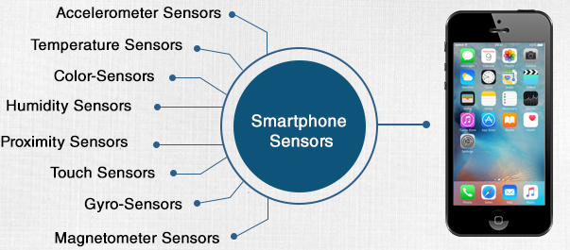

Fig 5: - Sensors in smartphones [2]

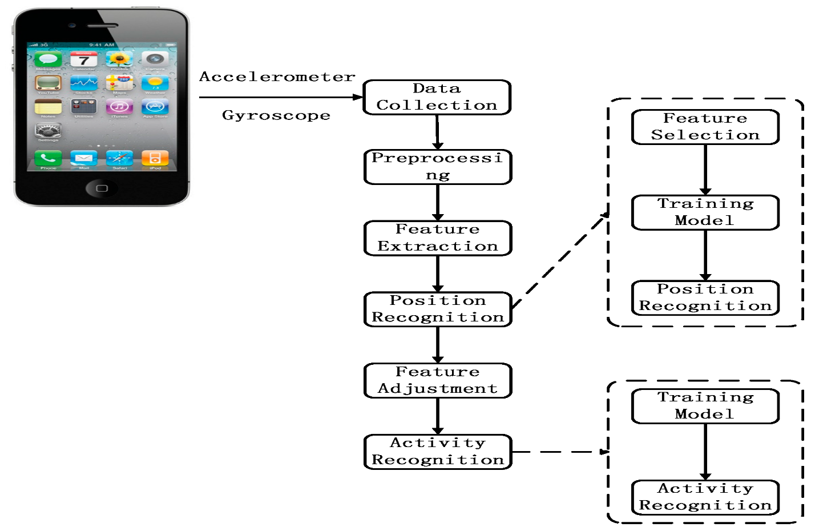

Fig 6: - Process of storing and collecting sensored data from smartphones [2]

**Results: -**

1. Machine Learning Algorithms: -

From the experiment, we can say that the best machine learning model to design these sensor is Linear SVC with 96.67% accuracy followed by RBF SVM Classifier with accuracy of 96.27%. Here we also logistic regression as a good model with 95.79% accuracy, Random Forest with accuracy of 91.89%, and Decision Tree with the lowest accuracy of 87.44%.

|  |  |
| --- | --- |
| **Machine Learning Model** | **Accuracy** |
| Linear Support Vector Classifier | 96.67% |
| RBF Support Vector Machine Classifier | 96.27% |
| Logistic Regression | 95.79% |
| Random Forest | 91.89% |
| Decision Tree | 87.44% |

Table 2 Machine Learning Model Comparison

Normalized Confusion Matrix Heatmap: -

Now we have normalized confusion matrix heatmap for all classical machine learning models. We can see that, Logistic Regression, Linear SVC and RBF SVM Classifier, the prediction accuracy of sitting is lowest as compared to other activities, as other prediction accuracy for other activities are more than 90%. And in case of Decision Tree, the prediction accuracies for sitting, standing, walking downstairs and walking upstairs are lowest and for lying down and walking are highest. Whereas, in case of Random Forest, the prediction accuracy for sitting and walking are lowest and for other activities the prediction accuracies are more than 90%.

Fig 7: - Confusion matrix heatmap for logistic regression

Fig 8: - Confusion matrix heatmap for Linear SVC

Fig 9: - Confusion matrix heatmap for RBF SVM Classifier

Fig 10: - Confusion matrix heatmap for Decision Tree

Fig 11:- Confusion matrix heatmap for Random Forest Classifier

1. Deep Learning Algorithms: -

Similarly from RNN LSTM deep learning algorithms we can say that, LSTM with 2-Layer (neurons:64, neurons:48) is the best RNN deep learning model to go forward with, which has accuracy of 91% and cross entropy value of 0.27.

|  |  |  |
| --- | --- | --- |
| **Deep Learning Algorithm** | **Cross Entropy** | **Accuracy** |
| LSTM with 1 – Layer (neurons:32) | 0.4785 | 91.95% |
| LSTM with 2 – Layer (neurons:48, neurons:32) | 0.4000 | 90.20% |
| LSTM with 2 – Layer (neurons:64, neurons:48) | 0.3400 | 92.13% |

Table 3 Deep Learning Model Comparison

**Conclusion: -**

From the above experiment when it comes to machine learning implementation for our problem, we can say that Linear SVC method is the best choice as it gives us highest accuracy of 96.47% accuracy as compared to other machine learning model.

For deep learning implementation we can say that LSTM with 2-Layer (neurons:64, neurons:48) is the best deep learning algorithm for our problem with highest accuracy of 91% and cross-entropy value of 0.27.

**References: -**

* <https://www.ijrte.org/wp-content/uploads/papers/v8i1/A1385058119.pdf>
* <https://archive.ics.uci.edu/ml/datasets/Smartphone-Based+Recognition+of+Human+Activities+and+Postural+Transitions>
* <https://www.geeksforgeeks.org/human-activity-recognition-using-deep-learning-model/>